Week-3: HTML5 and CSS
3a) Write a HTML program, that makes use of <article>, <aside>, <figure>, <figcaption>, <footer>, <header>, <main>, <nav>, <section>, <div>, <span> tags.
Description:

3 b) Write a HTML program, to embed audio and video into HTML web page
<!DOCTYPE html>
<html>
<head>
<title>Embedding Audio and Video</title>
</head>
<body>
<h2>HTML5 Audio and Video Embedding</h2>
<!-- Embed Audio -->
<section>
<h3>Audio Example:</h3>
<audio controls>
<source src="https://www.soundhelix.com/examples/mp3/SoundHelix-Song-1.mp3" type="audio/mpeg"> Your browser does not support the audio element.
</audio>
</section>
<br>
<!-- Embed Video -->
<section>
<h3>Video Example:</h3>
<video width="600" height="340" controls>
<source src="https://www.w3schools.com/html/mov_bbb.mp4" type="video/mp4">
Your browser does not support the video tag.
</video>
</section>
</body>
</html>

Output:
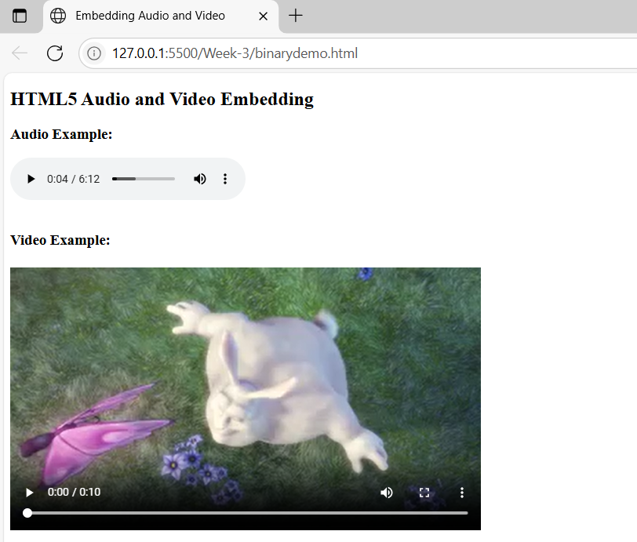

3 c) Write a program to apply different types (or levels of styles or style specification formats) -inline, internal, external styles to HTML elements. (identify selector, property and value).
Description:
CSS Style Specification Formats:
- Inline CSS – inside the HTML tag using style attribute
- Internal CSS – inside a <style> block in the <head>
- External CSS – in a separate .css file and linked using <link> (simulated here)

Each CSS rule has:
- Selector – the HTML element(s) to style
- Property – the style attribute to change
- Value – the setting for that property
Syntax:
selector {
property: value;
}
Example 1 (from inline CSS):
<h1 style="color: blue;">Hello</h1>
- Selector: h1 (implied, though it's inline)
- Property: color
- Value: blue

Example 2 (from internal CSS):
h2 {
color: darkgreen;
font-family: Georgia, serif;
}
Selector: h2
- First:
  - Property: color
  - Value: darkgreen
- Second:
  - Property: font-family
  - Value: Georgia, serif

Example 3 (from external CSS):
.external-paragraph {
font-size: 18px;
color: darkred;
}
Selector: .external-paragraph (a class selector)
- First:
  - Property: font-size
  - Value: 18px
- Second:
  - Property: color
  - Value: darkred

ID Selector:
Syntax:
#idname {
property: value;
}
Ex:
<!DOCTYPE html>
<html>
<head>
<style>
#highlight {
background-color: yellow;
border: 2px solid orange;
padding: 10px;
}
</style>
</head>
<body>
<p>This is a normal paragraph.</p>
<p id="highlight">This paragraph has an ID and special style.</p>
</body>
</html>

Code:
index.html:
<!DOCTYPE html>
<html lang="en">
<head>
<meta charset="UTF-8">
<title>CSS Styles Demo</title>
<!-- Internal CSS -->
<style>
h2 {
color: darkgreen;
font-family: Georgia, serif;
}
.internal-box {
background-color: lightyellow;
border: 2px solid orange;
padding: 10px;
}
</style>
<!-- External CSS -->
<link rel="stylesheet" type="text/css" href="styles.css">
</head>
<body>

<h1 style="color: blue; font-size: 28px;">Inline Styled Heading (h1)</h1>
<h2>Internal Styled Heading (h2)</h2>
<div class="internal-box">
This box uses <strong>internal CSS</strong> for styling.
</div>
<br>
<p class="external-paragraph">
This paragraph is styled using <strong>external CSS</strong>.
</p>
</body>
</html>

styles.css:
/* External CSS styles */
.external-paragraph {
font-size: 18px;
color: darkred;
background-color: #f0f0f0;
padding: 12px;
border-left: 4px solid red;
}

Output:
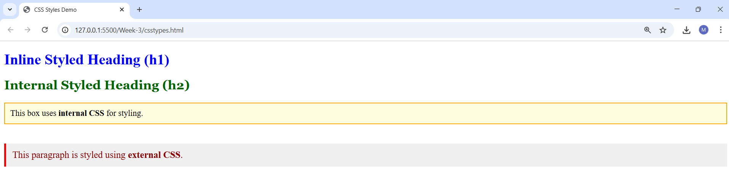

Viva Questions:

1. What is the purpose of the <article> tag in HTML?
Ans) The <article> tag is used to represent independent, self-contained content such as blog posts, news articles, or forum posts.

2. What does the <aside> tag represent in HTML?
Ans) The <aside> tag is used for content that is tangentially related to the main content, like sidebars, tips, or advertisements.

3. What is the <figure> tag used for?
Ans) The <figure> tag is used to enclose media or illustrations, such as images, diagrams, or code snippets.

4. What is the role of <figcaption> in HTML?
Ans) The <figcaption> tag provides a caption or description for the content inside the <figure> tag.

5. What does the <footer> tag define?
Ans) The <footer> tag represents the footer of a document or a section, typically containing copyright, contact info, or related links.

6. What is the <header> tag used for?
Ans) The <header> tag defines the introductory content or navigation links for a section or entire webpage.

7. What is the use of the <main> tag in HTML5?
Ans) The <main> tag specifies the central content of a webpage that is unique and not repeated across pages like headers or footers.

8. What is the purpose of the <nav> tag?
Ans) The <nav> tag is used to define a section that contains navigation links like menus, tables of contents, etc.

9. How is the <section> tag different from <div>?
Ans) <section> is a semantic tag used to group related content with a heading, while <div> is a generic container without any semantic meaning.

10. What is the difference between <div> and <span> tags?
Ans) <div> is a block-level container used for structuring page layout, while <span> is an inline container used for styling small portions of text.

Week-4: Selector Forms
4 a) Write a program to apply different types of selector forms
i. Simple selector (element, id, class, group, universal)
ii. Combinator selector (descendant, child, adjacent sibling, general sibling)
iii. Pseudo-class selector
iv. Pseudo-element selector
v. Attribute selector

Description:
Selector Type |  | Example |  | Description
Element |  | h1 |  | Selects all <h1>
ID |  | #main-title |  | Selects element with that ID
Class |  | .highlight |  | Selects elements with that class
Group |  | h2, p, li |  | Applies same rule to multiple elements
Universal |  | * |  | Applies to all elements
Combinator | Example |  | Matches...
Descendant | div p |  | All <p> inside <div>
Child | ul > li |  | Direct children only
Adjacent | h3 + p |  | First <p> immediately after <h3>
General | h3 ~ p |  | All <p> after <h3> siblings

Pseudo-class |  | Example
:hover |  | Link effects
:first-child, :nth-child(n) |  | Position-based selection
Pseudo-element | Example
::first-line | Style first line of text
::before, ::after | Inject content before/after element

Explanation Summary:

Attribute Selector | Example
[type="text"] | Exact attribute value
[href^="https"] | Starts with https
[placeholder*="name"] | Contains "name"

Code:
<!DOCTYPE html>
<html lang="en">
<head>
<meta charset="UTF-8">
<title>CSS Selector Types Demo</title>
<style>
/* I. Simple Selectors */
h1 { color: darkblue; } /* Element selector */
#main-title { text-decoration: underline; }/* ID selector */
.highlight { background-color: yellow; } /* Class selector */
h2, p, li { font-family: Arial, sans-serif; } /* Group selector */
* { margin: 5px; } /* Universal selector */

/* II. Combinator Selectors */
div p { color: green; } /* Descendant selector */
ul > li { font-weight: bold; } /* Child selector */
h3 + p { color: red; } /* Adjacent sibling */
h3 ~ p { font-style: italic; } /* General sibling */
/* III. Pseudo-class Selectors */
a:hover { color: orange; } /* Hover effect */
li:first-child { color: purple; } /* First child */
li:nth-child(2) { color: teal; } /* Specific child */

/* IV. Pseudo-element Selectors */
p::first-line { font-weight: bold; } /* First line of a paragraph */
p::before { content: "👉 "; color: gray; } /* Before content */
p::after { content: " ✅"; color: green; } /* After content */

/* V. Attribute Selectors */
input[type="text"] { border: 2px solid blue; }
a[href^="https"] { font-style: italic; }
input[placeholder*="name"] { background-color: #f0f8ff; }

</style>
</head>
<body>

<!-- Simple Selectors -->
<h1 id="main-title">CSS Selector Examples</h1>
<h2 class="highlight">This is a highlighted heading</h2>

<!-- Combinator Selectors -->
<div>
<p>This paragraph is a descendant of a div.</p>
</div>

<ul>
<li>First Item</li>
<li>Second Item</li>
<li>Third Item</li>
</ul>

<h3>Heading for siblings</h3>
<p>This paragraph is adjacent sibling of h3.</p>
<p>This paragraph is a general sibling of h3.</p>

<!-- Pseudo-class -->
<a href="https://www.example.com">Visit Example</a>

<!-- Pseudo-element -->
<p>This paragraph demonstrates pseudo-elements.</p>

<!-- Attribute Selectors -->
<form>
<input type="text" placeholder="Enter your name">
<input type="email" placeholder="Enter your email">
</form>

</body>
</html>

Output:

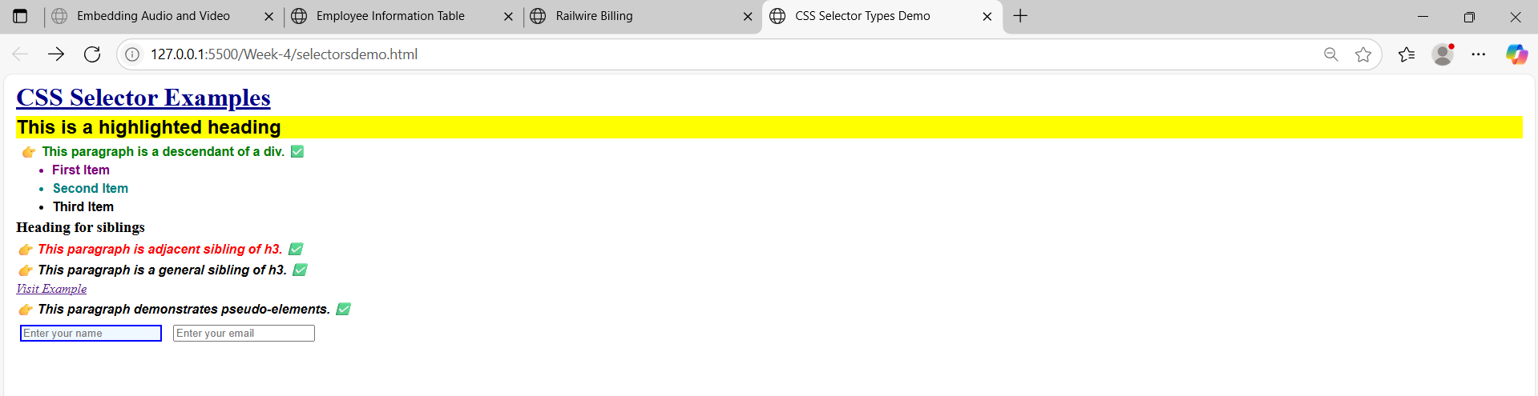

Viva Questions:
1. What is an element selector in CSS?
Ans) It selects HTML elements by their tag name.
Example: p { color: blue; } selects all <p> tags.

2. What is an ID selector?
Ans) It selects an element with a specific ID using #.
Example: #header { background: yellow; }

3. What is a class selector?
Ans) It selects all elements with a specific class using ..
Example: .box { border: 1px solid black; }

4. What is a group selector?
Ans) It groups multiple selectors to apply the same styles.
Example: h1, h2, h3 { font-weight: bold; }

5. What is the universal selector?
Ans) It selects all elements on the page using *.
Example: * { margin: 0; padding: 0; }

6. What is a descendant selector?
Ans) It selects all elements inside a specified element.
Example: div p { color: green; } selects all <p> inside <div>.

7. What is a child selector?
Ans) It selects direct child elements only using >.
Example: ul > li { list-style: none; }

8. What is an adjacent sibling selector?
Ans) It selects the next sibling immediately after a specified element using +.
Example: h1 + p { color: red; }

9. What is a general sibling selector?
Ans) It selects all siblings after the specified element using ~.
Example: h1 ~ p { font-style: italic; }

10. What is a pseudo-class in CSS?
Ans) It defines a special state of an element using :.
Example: a:hover { color: orange; }

11. What does :first-child do?
Ans) Selects the first child of a parent.
Example: li:first-child { color: red; }

12. What does :nth-child(n) do?
Ans) Selects the nth child of a parent.
Example: li:nth-child(2) { color: blue; }

13. What is a pseudo-element in CSS?
Ans) It styles specific parts of an element using ::.
Example: p::first-line { font-weight: bold; }

14. What does ::before do?
Ans) Inserts content before an element.
Example: h1::before { content: "★ "; }

15. What is an attribute selector in CSS?
Ans) It selects elements based on the presence or value of an attribute.
Example: input[type="text"] { border: 1px solid gray; }

